PD Express Login
http://10.88.2.5/pdexpress/
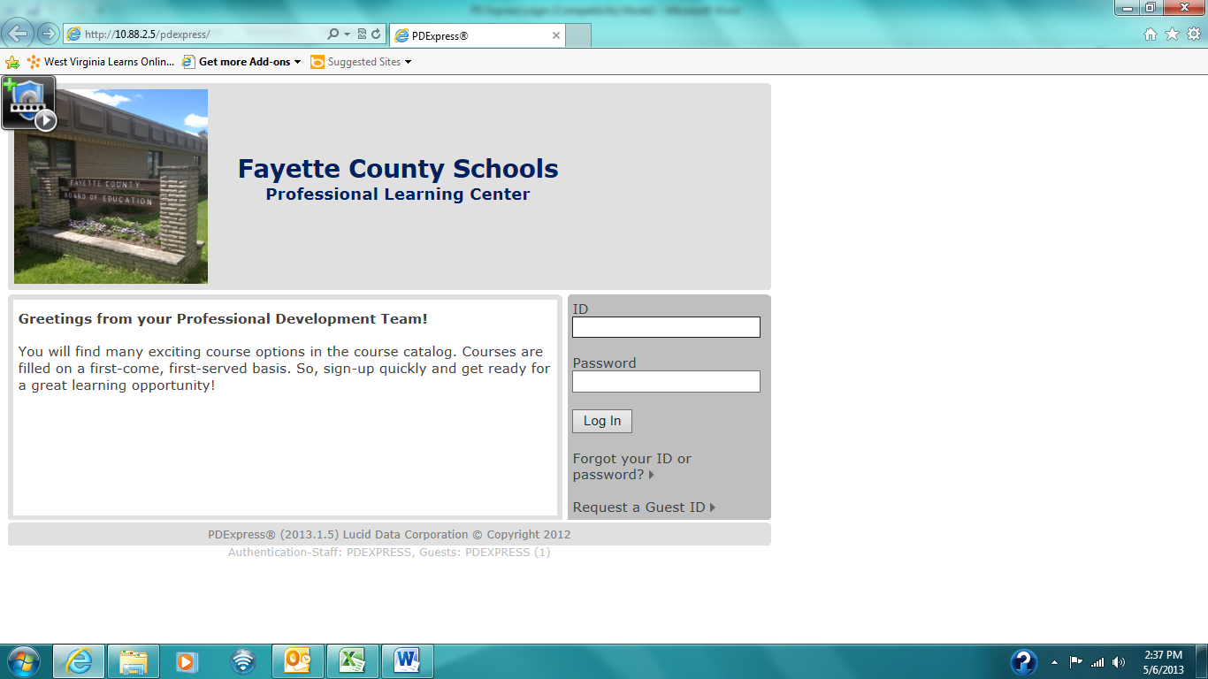
Step 2: Enter Employee ID #
(92000----) for Password PaPassPassword
Step 1: Enter Employee ID #
(92000----) for ID

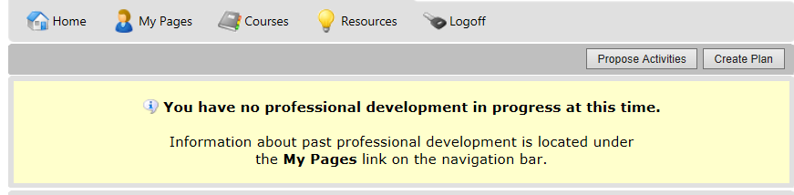
Step 3: Choose Courses and then Course Catalog from the drop-down menu.
Step 4: Click the Register button to the left of the course date.

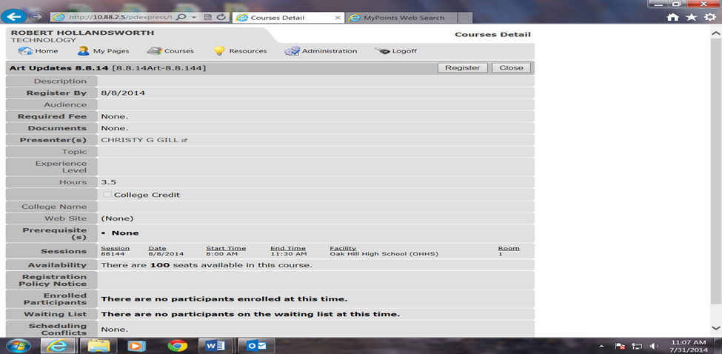
Step 5: Click the Register button
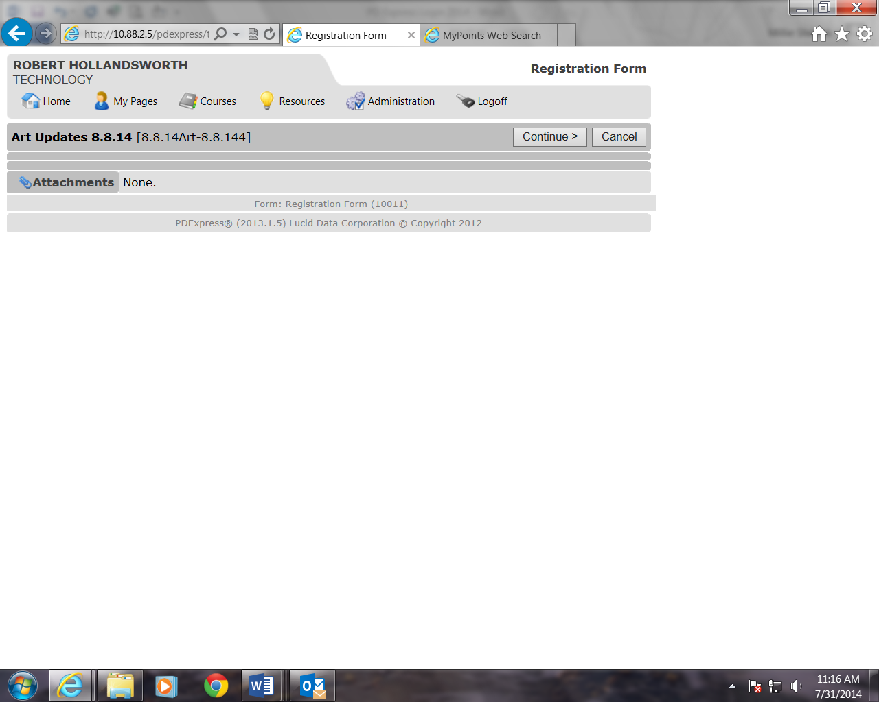
Step 6: Click the Continue button to complete your registration
You should receive a Congratulation confirmation.

