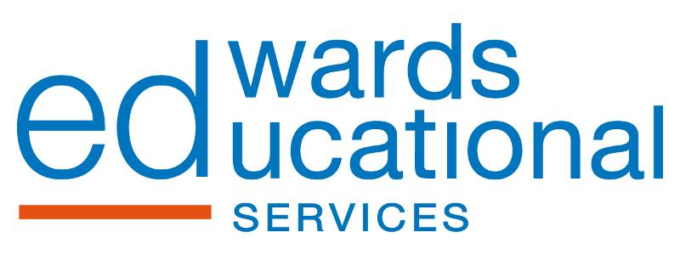 VALLEY

VALLEY HIGH SCHOOL WIDE PBL RATIONALE

The Valley community has faced many challenges over the past decade or so- decline of industry, population, and loss of WVU Tech was a huge blow, and we felt that our best approach to improve school climate, learning, and to connect to the community was to focus on our home area. Our overarching topic at Valley for 2017-2018 was the UKV (Upper Kanawha Valley.) We did PBLs each quarter addressing aspects of the UKV, and each quarter had an embedded skillset.

At the end of the year students -fueled by their PBL school wide study of the UKV- worked to connect to the community with a culminating project by creating a mural next to city hall, the senior center, and the police & fire stations in Smithers. The art department spearheaded the work here, with our students from all content areas working with the community- parents along with the Montgomery Art Group -to bring the idea to reality.

Last year we looked at how the UKV impacts Valley High School.
This next year we will look at how our school can impact the community.

Year 1- UKV- How the UKV community influences our school (and its stakeholders)
Year 2- UKV- How our school (and its stakeholders) influences our UKV community
PBL Year Two Focus on Quality
STANDARDS, BACKWARDS DESIGN, AUTHENTIC ASSESSMENT

Next Year’s Plan

O V E R A R C H I N G T O P I C
Valley High School’s
PASSPORT TO THE FUTURE

1st Quarter  Subtopic | 2nd Quarter  Subtopic | 3rd Quarter  Subtopic | 4th Quarter  Subtopic
ADAPT | ACHIEVE | ADVANCE | ACT
Skill | Skill | Skill | Skill
INFER | SUMMARIZE | COMPARE & CONTRAST | CREATE

ARTIFACT

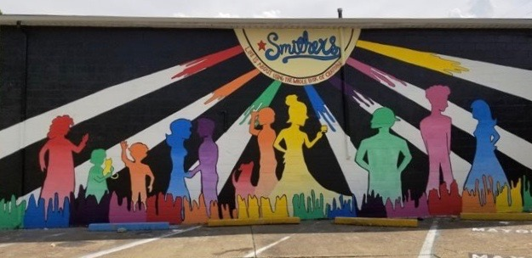

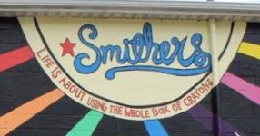

2017-2018 PBL Mural Topic

“Life is About Using the Whole Box of Crayons”

