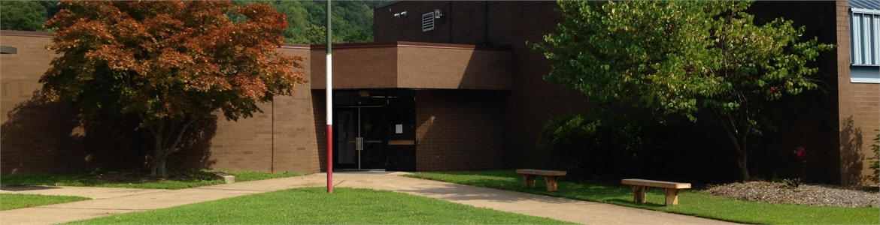

VALLEY ELEMENTARY
SUCCESS

Thursday, March 7, 2018

AGENDA

Review recurring points

- Standards- Deconstruction
- Assessment
- PALs – Benchmark updates
- DOK Levels
- Always bring Data!
- What did you bring to share?

Today’s Topics

- PBL benefits
- Standards driven
- Seven Essentials for a PBL referenced
- DOK Levels
- PBL PBL PBL

Action Steps
- PBL –time to roll!
- Collaborate with Leadership Members both schools
- Brainstorm- focus- action!
- Take ideas and put on PBL template
- Make sure STANDARDS drive your PBL
- Plan implementation
- Support is provided
- Target completion by next meeting

